REQUEST FOR PROPOSALS
SAMPLE
{TYPE OF PLAN}
Template Last Updated: 6/23/2026

ISSUED BY: {APPLICANT AND/OR AGENT OF THE APPLICANT}
{ADDRESS}
DUE DATE: {TIME AND DATE}

INTRODUCTION

{Applicant and/or Agent of the Applicant (and any other partners)} is seeking proposals from qualified consulting firms to develop a {Type of Plan}. This plan will outline objectives and goals for developing the plan.

PROJECT BACKGROUND

{Overview of community and need for Plan}.

{Brief summary of Scope of Work}.

SCOPE OF WORK
Project will be partially funded by the Wyoming Business Council (WBC). The WBC’s approach to economic development focuses on identifying problems and breaking down barriers obstructing a more resilient economy. The selected consultant will be familiar with the Economic Growth Flywheel and will approach this Plan by targeting specific needs and working with {Applicant and/or Agent of Applicant and its partners} on our individual and unique economic issues.
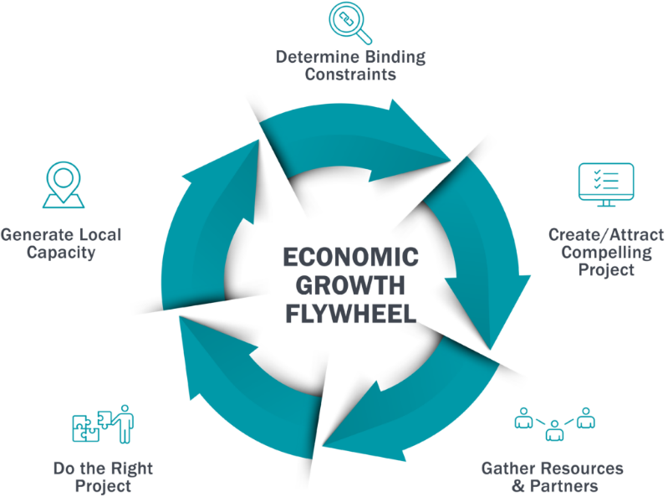

Scope of Services:
The information outlined below strives to describe the approximate scope of services to be provided by the consultant. This outline is not all inclusive.

Examples Only:
- Determine community’s unique economic barriers to growth
- Analysis of economic activity and recommended areas for growth potential
- Identify key industries and sectors that are poised for growth and how the community can best attract this development
- Analysis of the community’s policies, infrastructure, amenities, etc. and how they relate to business attraction and retention
- Examine the housing market and identify approaches to housing development

The selected consultant will perform the following tasks:

Examples Only:
- Project Kickoff and Community Engagement
  - Conduct a project kickoff meeting
  - Develop a comprehensive engagement plan to include public meetings, surveys, and workshops
  - Facilitate interviews with elected officials, department heads, business leaders, and community groups
- Data Collection and Barrier to Growth Analysis
  - Research existing data and information
  - Evaluate existing infrastructure, transportation, housing, and economic data
  - Analyze demographic trends and workforce needs to inform growth strategies
  - Evaluate existing conditions which include transportation, utilities, housing, etc.
  - Determine Barriers to Economic Growth
- Plan Development
  - Draft a comprehensive economic development master plan
  - Develop actionable recommendations for addressing barriers to growth
- Funding and Implementation Strategy
  - Identify state, federal, and private funding sources for priority projects
  - Create a phased implementation timeline with detailed cost estimates
  - Develop performance metrics to monitor progress and success
- Draft and Final Plan Presentation
  - Present the draft plan to {Applicant and/or Agent of Applicant and any partners} for feedback.
  - Revise the plan based on input and present the final plan at public meeting(s).
  - Provide all final documents in accessible digital formats and printed copies.

PROPOSAL SUBMISSION
The proposal shall include:

- Cover Letter
  - Firm Introduction and summarize relevant qualifications
- Firm Profile and Experience
  - Overview of the Firm, including relevant experience in economic development and regional planning.
  - Highlight past projects of similar scope.
- Approach and Methodology
  - Describe the approach for achieving project objectives, including methods for community engagement and analysis.
- Proposed Team
  - List key team members and their resumes, including subconsultants
- Work Plan and Timeline
  - Provide a detailed work plan, including milestones and deliverable timelines.
- Cost Proposal
  - Submit a detailed budget, including fees, travel, and other expenses.
- References
  - Provide at least three (3) references from similar projects, including contact information.

Submit proposals electronically in PDF format to:
{Name}
{Email Address}

Alternatively, mail hard copies to:
{Name}
{Address}

All proposals must be received by {Time and/or Date}. Late submissions will not be considered.

Additional Information:

The {Applicant and/or Agent of the Applicant} reserves the right to reject any or all proposals, request additional information, or negotiate terms with the selected firm. This RFP does not obligate {Applicant and/or Agent of Applicant} to award a contract or reimburse any costs incurred in the preparation of a proposal.

For questions or clarifications, contact:
{Name}
{Email Address}
{Phone Number}

